

**Exercise: Basic Linux & Bash commands**

**================================================================================ ==============================================**

**On Hyper-V/Oracle/VMware (whatever your preferred Linux workaround is currently) download Ubuntu image and install it as a virtual machine or WSL2. After this is done:**

1. **Create a file friends.txt with a list of names of three of your friends on separate lines.**
2. **Display the contents of friends.txt on the console.**

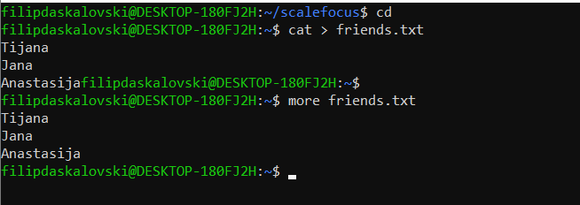

1. **Rename file friends.txt to bestfriends.txt**

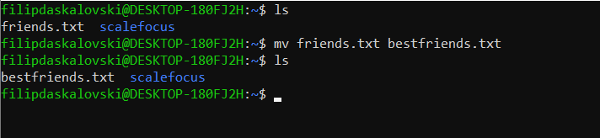

1. **Make a copy of bestfriends.txt under the name sysadmins.txt**

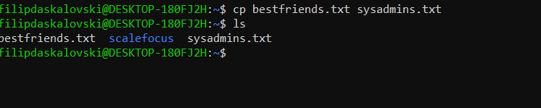

1. **List all files whose name begins with letter 'b' and ends with extension txt.**

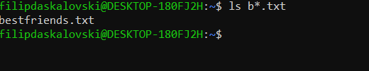

1. **Write a command that will tell you how many bytes are taken up by file sysadmins.txt**

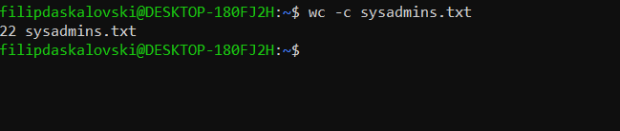

1. **Create file cars.txt with a list of 5 brands of cars on separate lines.**

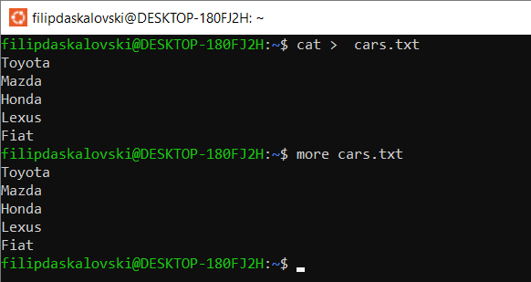

1. **Check how many bytes are taken up by the file.**

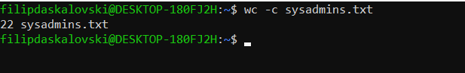

1. **Copy the file cars.txt into directory /tmp**

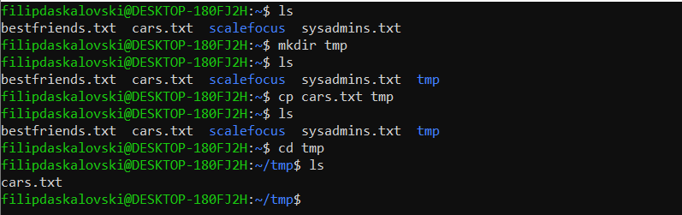

1. **List all files with extension *.txt in directory /tmp and verify that the file was copied properly.**

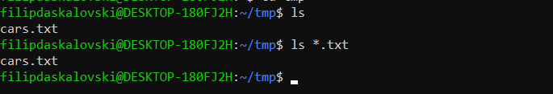

1. **Without leaving your home directory rename file cars.txt located in /tmp to vehicles.txt in /tmp**

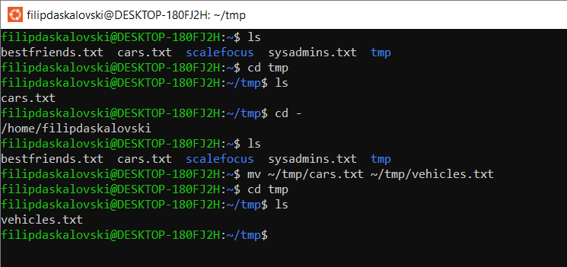

1. **Display the contents of /etc/passwd file on the screen interactively (so you can search, scroll up and down)**

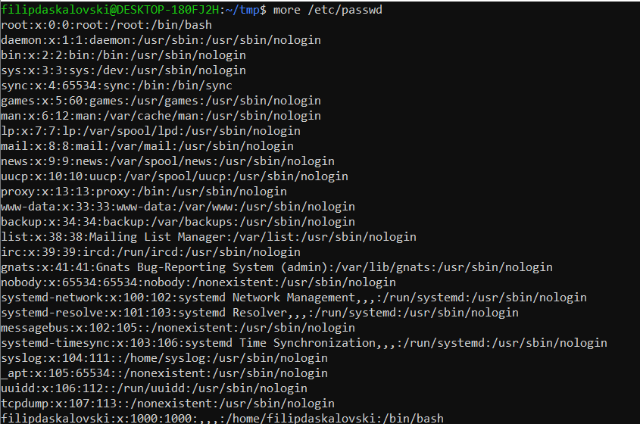

**69 Bulgaria Blvd., Infinity Tower B, fl. 8, Triaditza district, 1404 Sofia, Bulgaria | +359 2424 6484 | sales@scalefocus.com | www.scalefocus.com**